McDonald’s Homegrown Huskies
Sales Contract
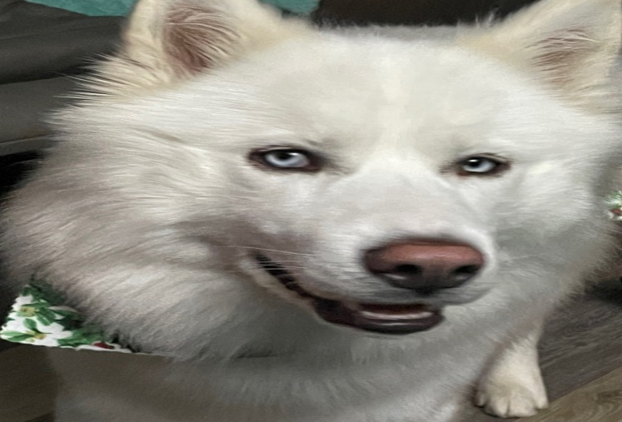
April McDonald
149 Sugar Lane, Lily Ky 40740
Cell: 606-231-4035
Email: amcdonald149@icloud.com Website: mcdonaldhuskies.com
All puppies sold are vet checked with first shots/deworming. Both seller and buyer agree this puppy is in good health at the date and signing of this contract. There are no refunds of money period. At signing of this contract, the seller is no longer responsible for the health of the puppy, or any veterinarian bills acquired. Buyer has 72 hours to have puppy examined by a licensed veterinarian. If the veterinarian finds a life-threatening genetic defect (such as a level 4 heart murmur) it may be eligible to exchange out for a similar puppy when available. Parvovirus is not considered a genetic defect and is not covered under this contract. A puppy that has had age-appropriate vaccines is still prone to catch parvovirus. The buyer is to notify the seller during the 72 hours and provide a letter from the veterinarian explaining the findings. The seller will determine if the puppy is eligible to exchange based on letter. If a puppy is exchanged, the buyer is responsible for any transportation. This puppy is not guaranteed to be of breeding or show quality.
Breed of Puppy: Siberian Husky Date of Birth: Male/Female AKC/CKC
Sire/Dad: McDonald’s Montana Mountain Avalanche Dam/Mom: McDonald’s Montana Blue Luna
Name of Buyer: ____________________________________________
Address of Buyer: __________________________________________Phone # of Buyer: _____________
Signature of Seller: _________________________________________Date of Sale: ________________
Signature of Buyer: _________________________________________

